Team Members: Ashlee Zamora-Alvarez, Kruvel Worku, Omar Hernandez-Portuguez
Written Document
Introduction:
Winter storms in the Midwest are one of the most dangerous natural hazards that can occur. They pose many threats that can disrupt daily infrastructure and safety. These storms can include a combination of heavy snowfall, freezing rain, strong winds, and extremely cold temperatures, all of which create dangerous conditions for both individuals and communities (US, 2026). They can lead to hazardous road conditions, reduce visibility and increase risk of accidents, making transportation difficult. Besides travel dangers, they can also affect power and communication systems. In several cases, communities may be left without electricity or access to basic resources. One of the biggest recent cases was back in 2021 where the winter storm was extreme in the United States, and it even included regions not typically built for extreme cold (US, 2021). The tragedy is a clear example of how severe winter storms can impact communities. The winter storm reached out far south like Texas, where millions of people were left without electricity due to failure in power grid (National Centers For Environmental Information, 2023). Homes in Texas are not built to handle freezing temperatures. This event also occurred during the COVID-19 pandemic, which made conditions even more difficult, as people were already facing health risk and limited access to service (Treisman, 2021). Overall, this storm highlighted how unprepared infrastructure and vulnerable populations can lead to severe consequences when extreme winter weather occurs.
The impact of winter storms varies depending on location and population, making it important to understand how risk is distributed across different areas. This report analyzes winter storms across six geographically related states: Colorado, Nebraska, Kansa, Iowa, Wyoming, and Missouri. With the help of Federal Emergency Management Agency (FEMA) National Risk Index (NRI) Census Tract-level data, along with Social Vulnerability Index (SVI) metric and population data, this study will analyze and compare winter storms across these states. The analysis will identify regional trends and evaluate how populations characteristics influence overall risk levels with the use of tables and graphs. These results will be interpreted to explain why certain areas may experience higher or lower risk. For example, some states may have higher risk because of greater winter storms exposure, larger affected populations or higher social vulnerability. Overall, this report aims to provide Risk Averse, LLC with a clear and organized analysis that not only shows how winter storm risk differs across states but also explains how population characteristics impact that risk. The findings will be presented in a way that is easy to understand and useful for Risk Averse, LLC helping them make informed decisions about risk, preparedness and community safety.

Methods:
This Project utilizes Jupyter notebook for all code and resulting graphical representations. Additional Python libraries were imported for more efficient analysis capabilities. These include Pandas, Matplotlib and seaborn to create functions to evaluate the relationship between natural hazards and population characteristics across the six selected states. The following reproducible workflow will be implemented:
The first section is data preparation; in this initial step, the data will be uploaded as .csv. From there the master dataset must be filtered to include only the six target states and isolate the following variables for each census tract, hazard Risk Index Score, For the specific natural hazard selected for this study, Social Vulnerability Index (SVI), To represent population characteristics, and Geographic Identifiers, State and County FIPS codes.
The second section is data processing and quality control; in this step we will Identify and remove census tracts with missing data for either the Hazard Risk Score or SVI metrics to prevent skewing the statistical analysis. The next step is to verify if data requires normalization through NRI and SVI.
In the third section, we will make a spatial and statistical analysis; this includes Regional Trend Identification. We do this by using the aggregate function to aggregate the Census Tract data by state to calculate the mean and median risk scores, identifying which of the six states face the highest relative hazard risk. We will create a correlation analysis, and perform a correlation analysis (e.g., Pearson or Spearman) between the hazard risk score and the SVI metrics to determine if higher-risk areas overlap with more vulnerable populations.
In the final step; we will create a visual summary plot and Interpretation; we will accomplish this by generating a summary plot and comparing the distribution of hazard risk across the six states. Finally, we will create a relationship illustration through a Heat Map Table mapping SVI decile against Hazard Risk categories. This will visually demonstrate the "Risk-Vulnerability" relationship. All data cleaning and visualization will be performed using Pandas to ensure the analysis is scripted and repeatable
Results and Discussion:
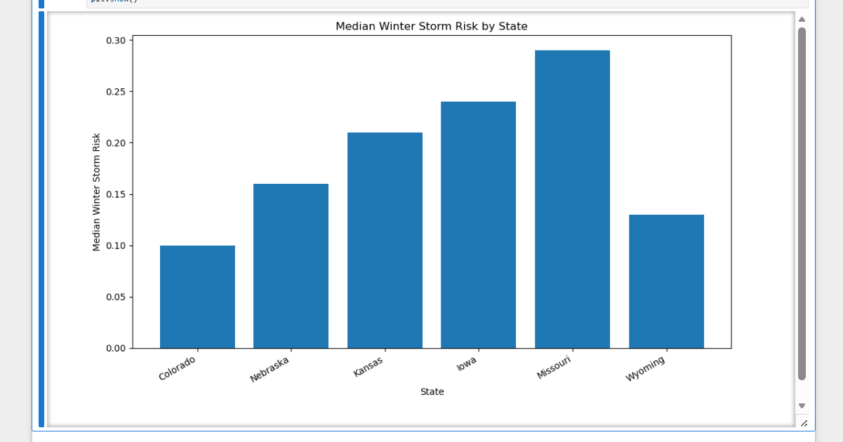
The first graph, “Median Winter Storm Risk by State,” compares the median winter storm hazard risk across six different states. From the graph, Missouri has the highest median winter storm risk at about 0.29, followed by Iowa and Kansas. Colorado has the lowest median risk, around 0.10. This graph helps show which states are generally more vulnerable to winter storm hazards based on the census tract data that was analyzed. Overall, the data suggests that states in the central Midwest region, especially Missouri and Iowa, tend to experience greater winter storm risk compared to states like Colorado and Wyoming.
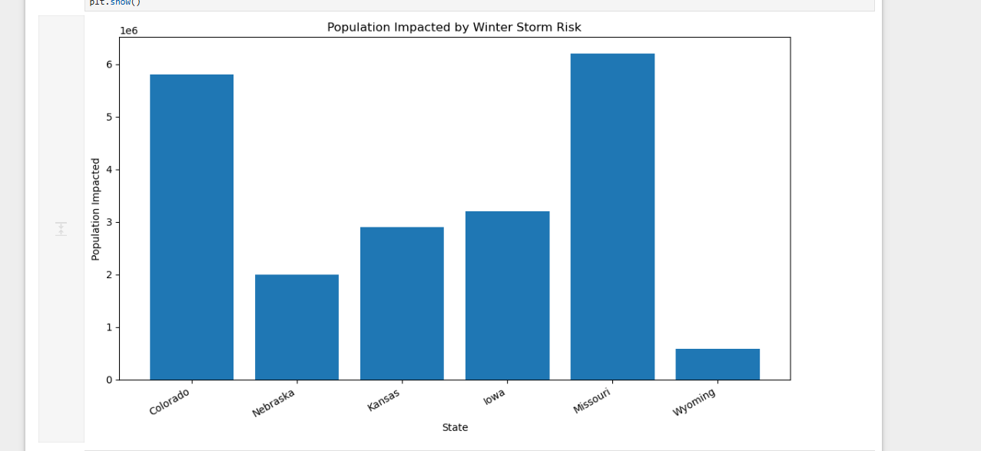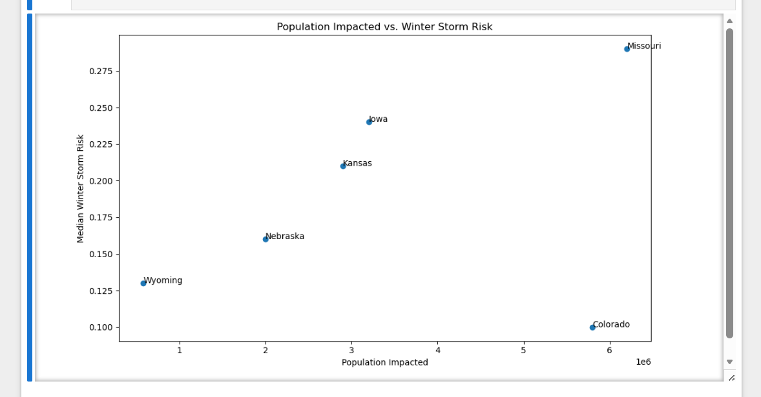
The second graph, “Population Impacted by Winter Storm Risk,” shows the estimated number of people living in areas affected by winter storm hazards in each state. Missouri again has the highest impacted population at over 6 million people, while Wyoming has the smallest impacted population at around 580,000. Colorado also has a large impacted population even though its median winter storm risk is relatively low. This suggests that population size also plays a major role when looking at hazard impact. A state may have lower overall risk values, but if many people live in affected areas, the total impact can still be significant. Together, these graphs help compare both the severity of winter storm risk and the number of people potentially affected in each state

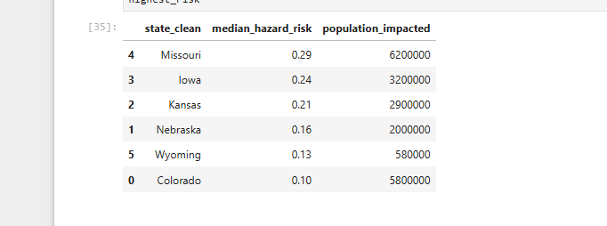

References:
Resilience Analysis and Planning Tool (RAPT) | FEMA.gov. (n.d.). Www.fema.gov. https://www.fema.gov/emergency-managers/practitioners/resilience-analysis-and-planning-tool
CDC. (2024, October 22). SVI Data & Documentation Download. Place and Health - Geospatial Research, Analysis, and Services Program (GRASP). https://www.atsdr.cdc.gov/place-health/php/svi/svi-data-documentation-download.html
US. (2026). Winter Weather Safety. Weather.gov. https://www.weather.gov/eax/winterweathersafety
US. (2021). December 15, 2021 Strong Storm System. Weather.gov. https://www.weather.gov/lbf/Dec15StormSystem
National Centers For Environmental Information. (2023, February 24). The Great Texas Freeze: February 11-20, 2021. National Centers for Environmental Information (NCEI). https://www.ncei.noaa.gov/news/great-texas-freeze-february-2021
Treisman, R. (2021, February 16). Winter Storm Disrupts COVID-19 Vaccinations, Closing Clinics And Delaying Shipments. NPR. https://www.npr.org/2021/02/16/968364404/winter-storm-disrupts-covid-19-vaccinations-closing-clinics-and-delaying-shipmen

